Task-2 Snowflake – Multi-Dataset Ingestion, Transformation & Query Performance Optimization
Aryan • RETAIL_DB_ARYAN / RAW_ARYAN • 4 November 2026
This task extended the existing Snowflake environment with three machine-related datasets. The datasets were loaded, checked, cleaned, and then used for analysis. The final part covered the main analytical query, which was corrected after its first version produced inflated maintenance totals.

1. Task overview
The task was to add a few new CSV datasets to the existing Snowflake database and make them usable for analysis. This covered creating the tables, loading the files, checking the row counts, and looking for nulls, duplicates and bad records, followed by cleaning where needed.
Analytical queries were then run across the three datasets. The main query was also rewritten, because the original join was repeating maintenance records and inflating the totals.

2. Environment used
No new database or warehouse was created. The work used the existing setup, which is shown in the screenshots:
Setting | Value
Database / Schema | RETAIL_DB_ARYAN / RAW_ARYAN
Warehouse | RETAIL_WH_ARYAN (X-Small)
Role | ACCOUNTADMIN

All the new tables end with _ARYAN, in line with the earlier naming, so the related tables sit together.
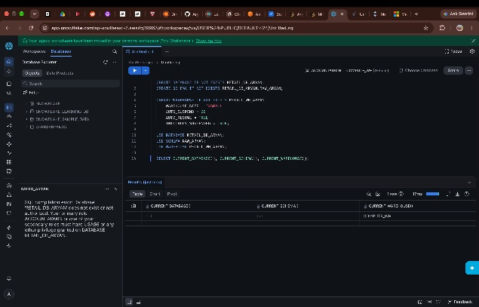
Figure 1 — Setting up the database, schema and warehouse used for this task.

3. Tables created
Table | What it holds | Rows
MACHINES_ARYAN | MACHINE_ID, MACHINE_TYPE, LOCATION, MANUFACTURER | 15*
SENSOR_READINGS_ARYAN | READING_ID, MACHINE_ID, TEMPERATURE_C, VIBRATION_MM_S, PRESSURE_PSI, RPM | 3,015
MAINTENANCE_LOGS_ARYAN | LOG_ID, MACHINE_ID, MAINTENANCE_TYPE, COST_INR, TECHNICIAN, DOWNTIME_HOURS | 138

* As shown in the row-count screenshot, which was a bit low-resolution.
The three tables cover different parts of the same data — one lists the machines, one holds their sensor readings, and one records what was spent maintaining them.
Each table was checked with DESC TABLE after creation to confirm that the columns and data types were correct.
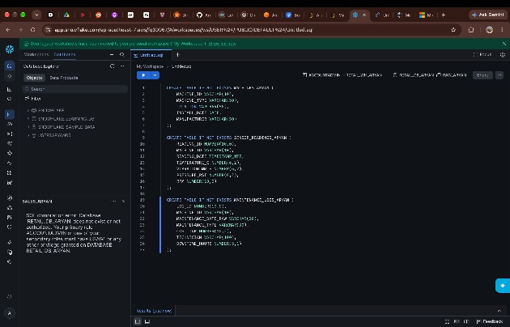
Figure 2 — Creating the three tables.
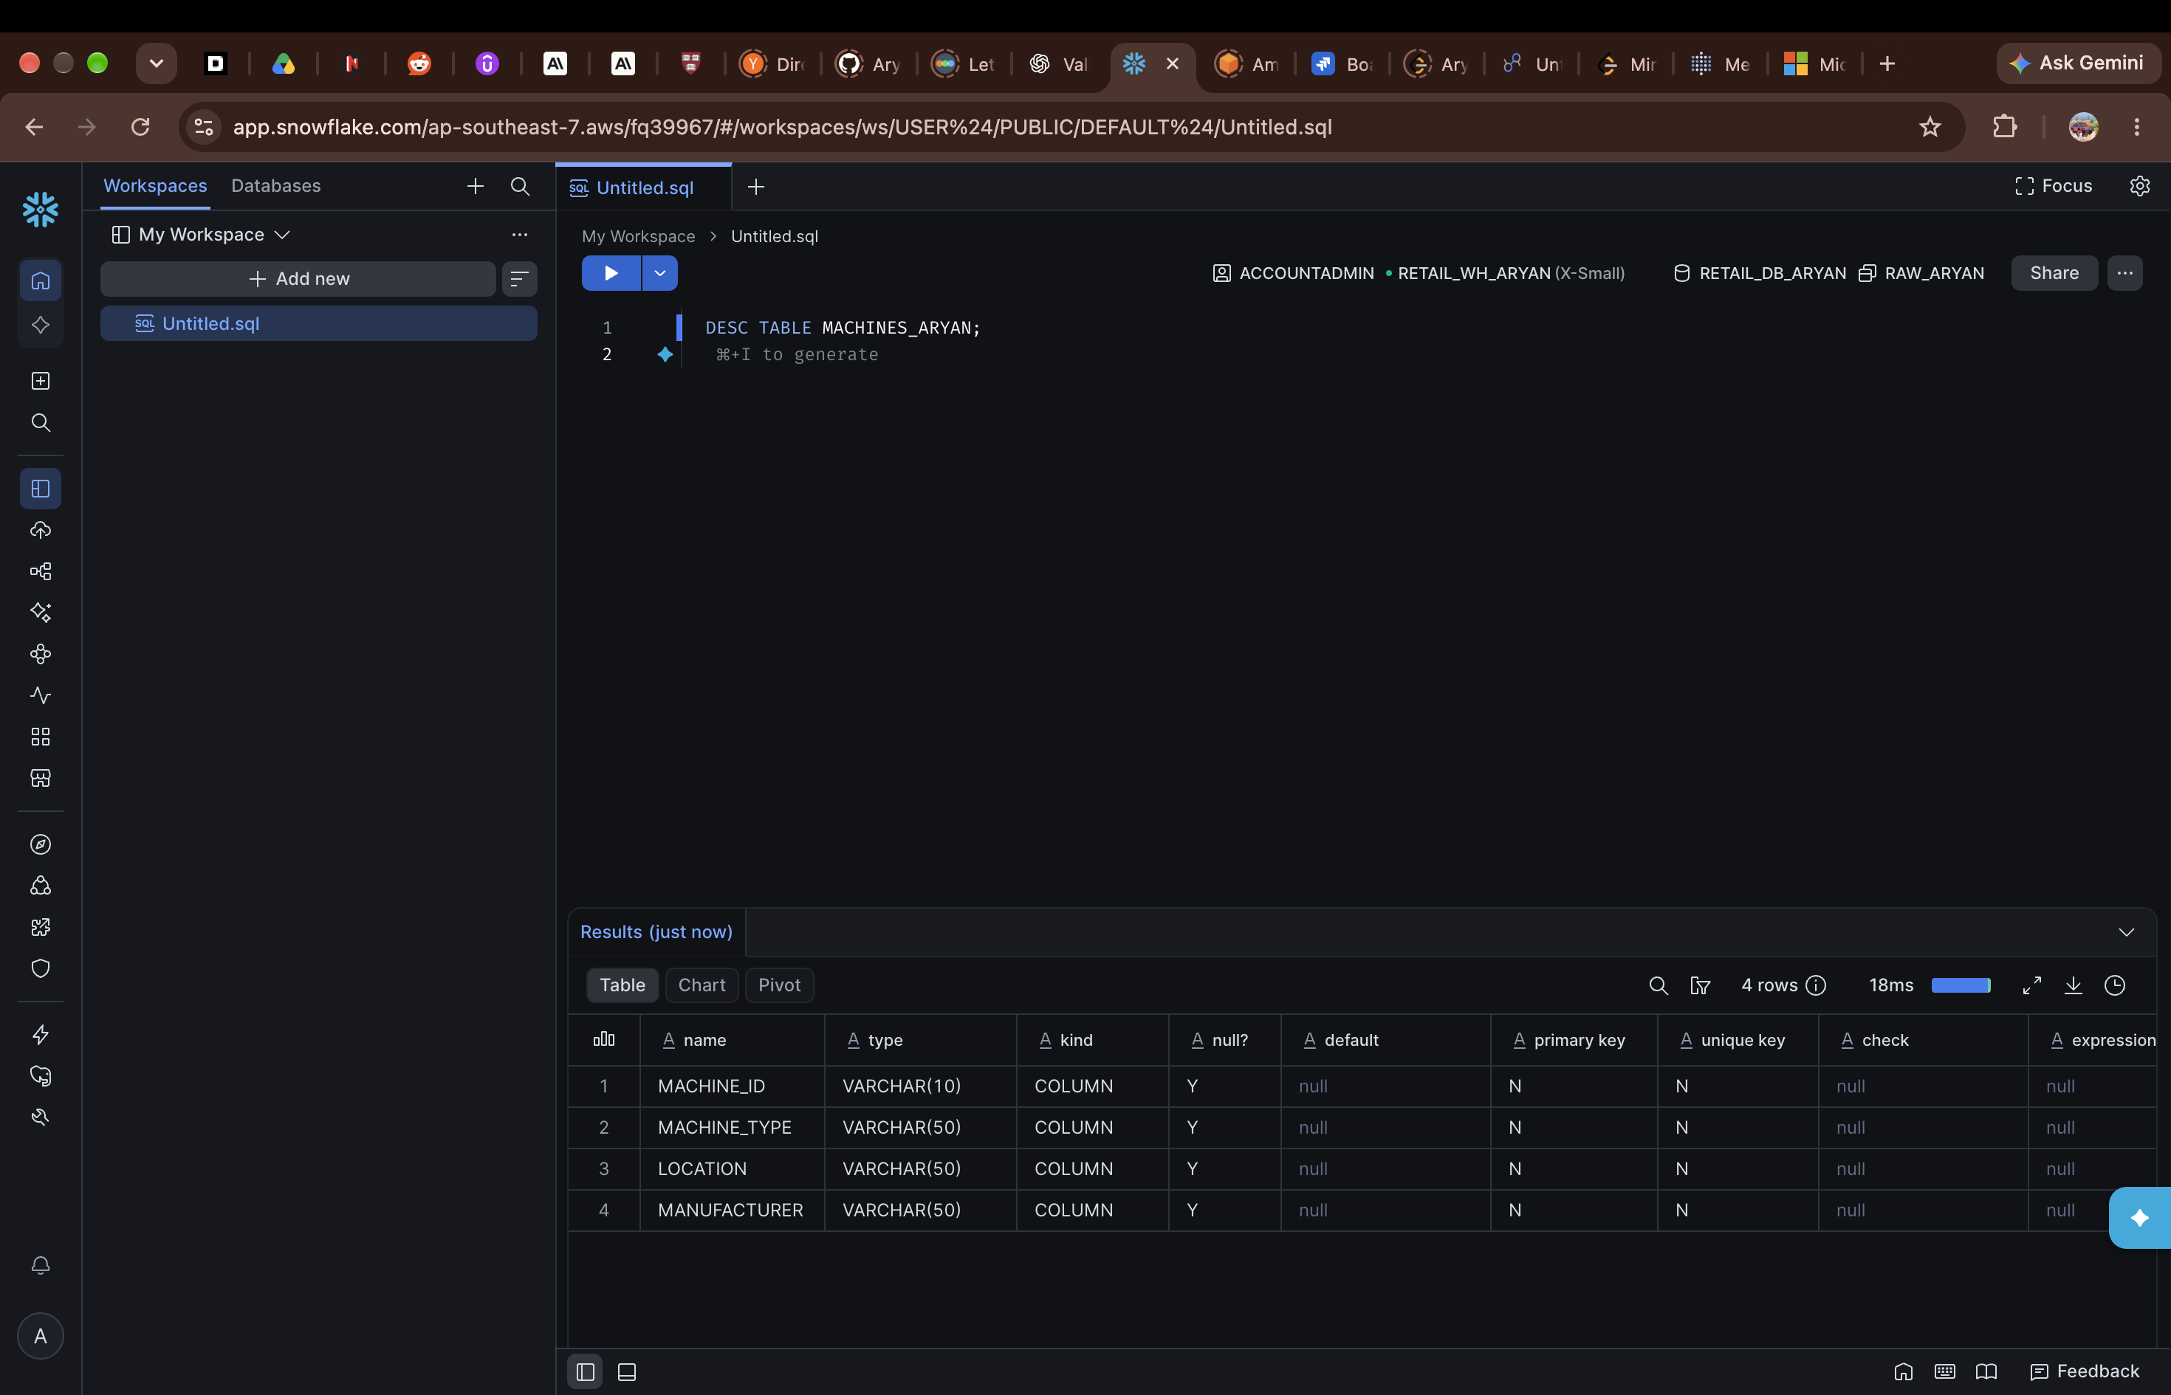
Figure 3 — Structure of MACHINES_ARYAN.
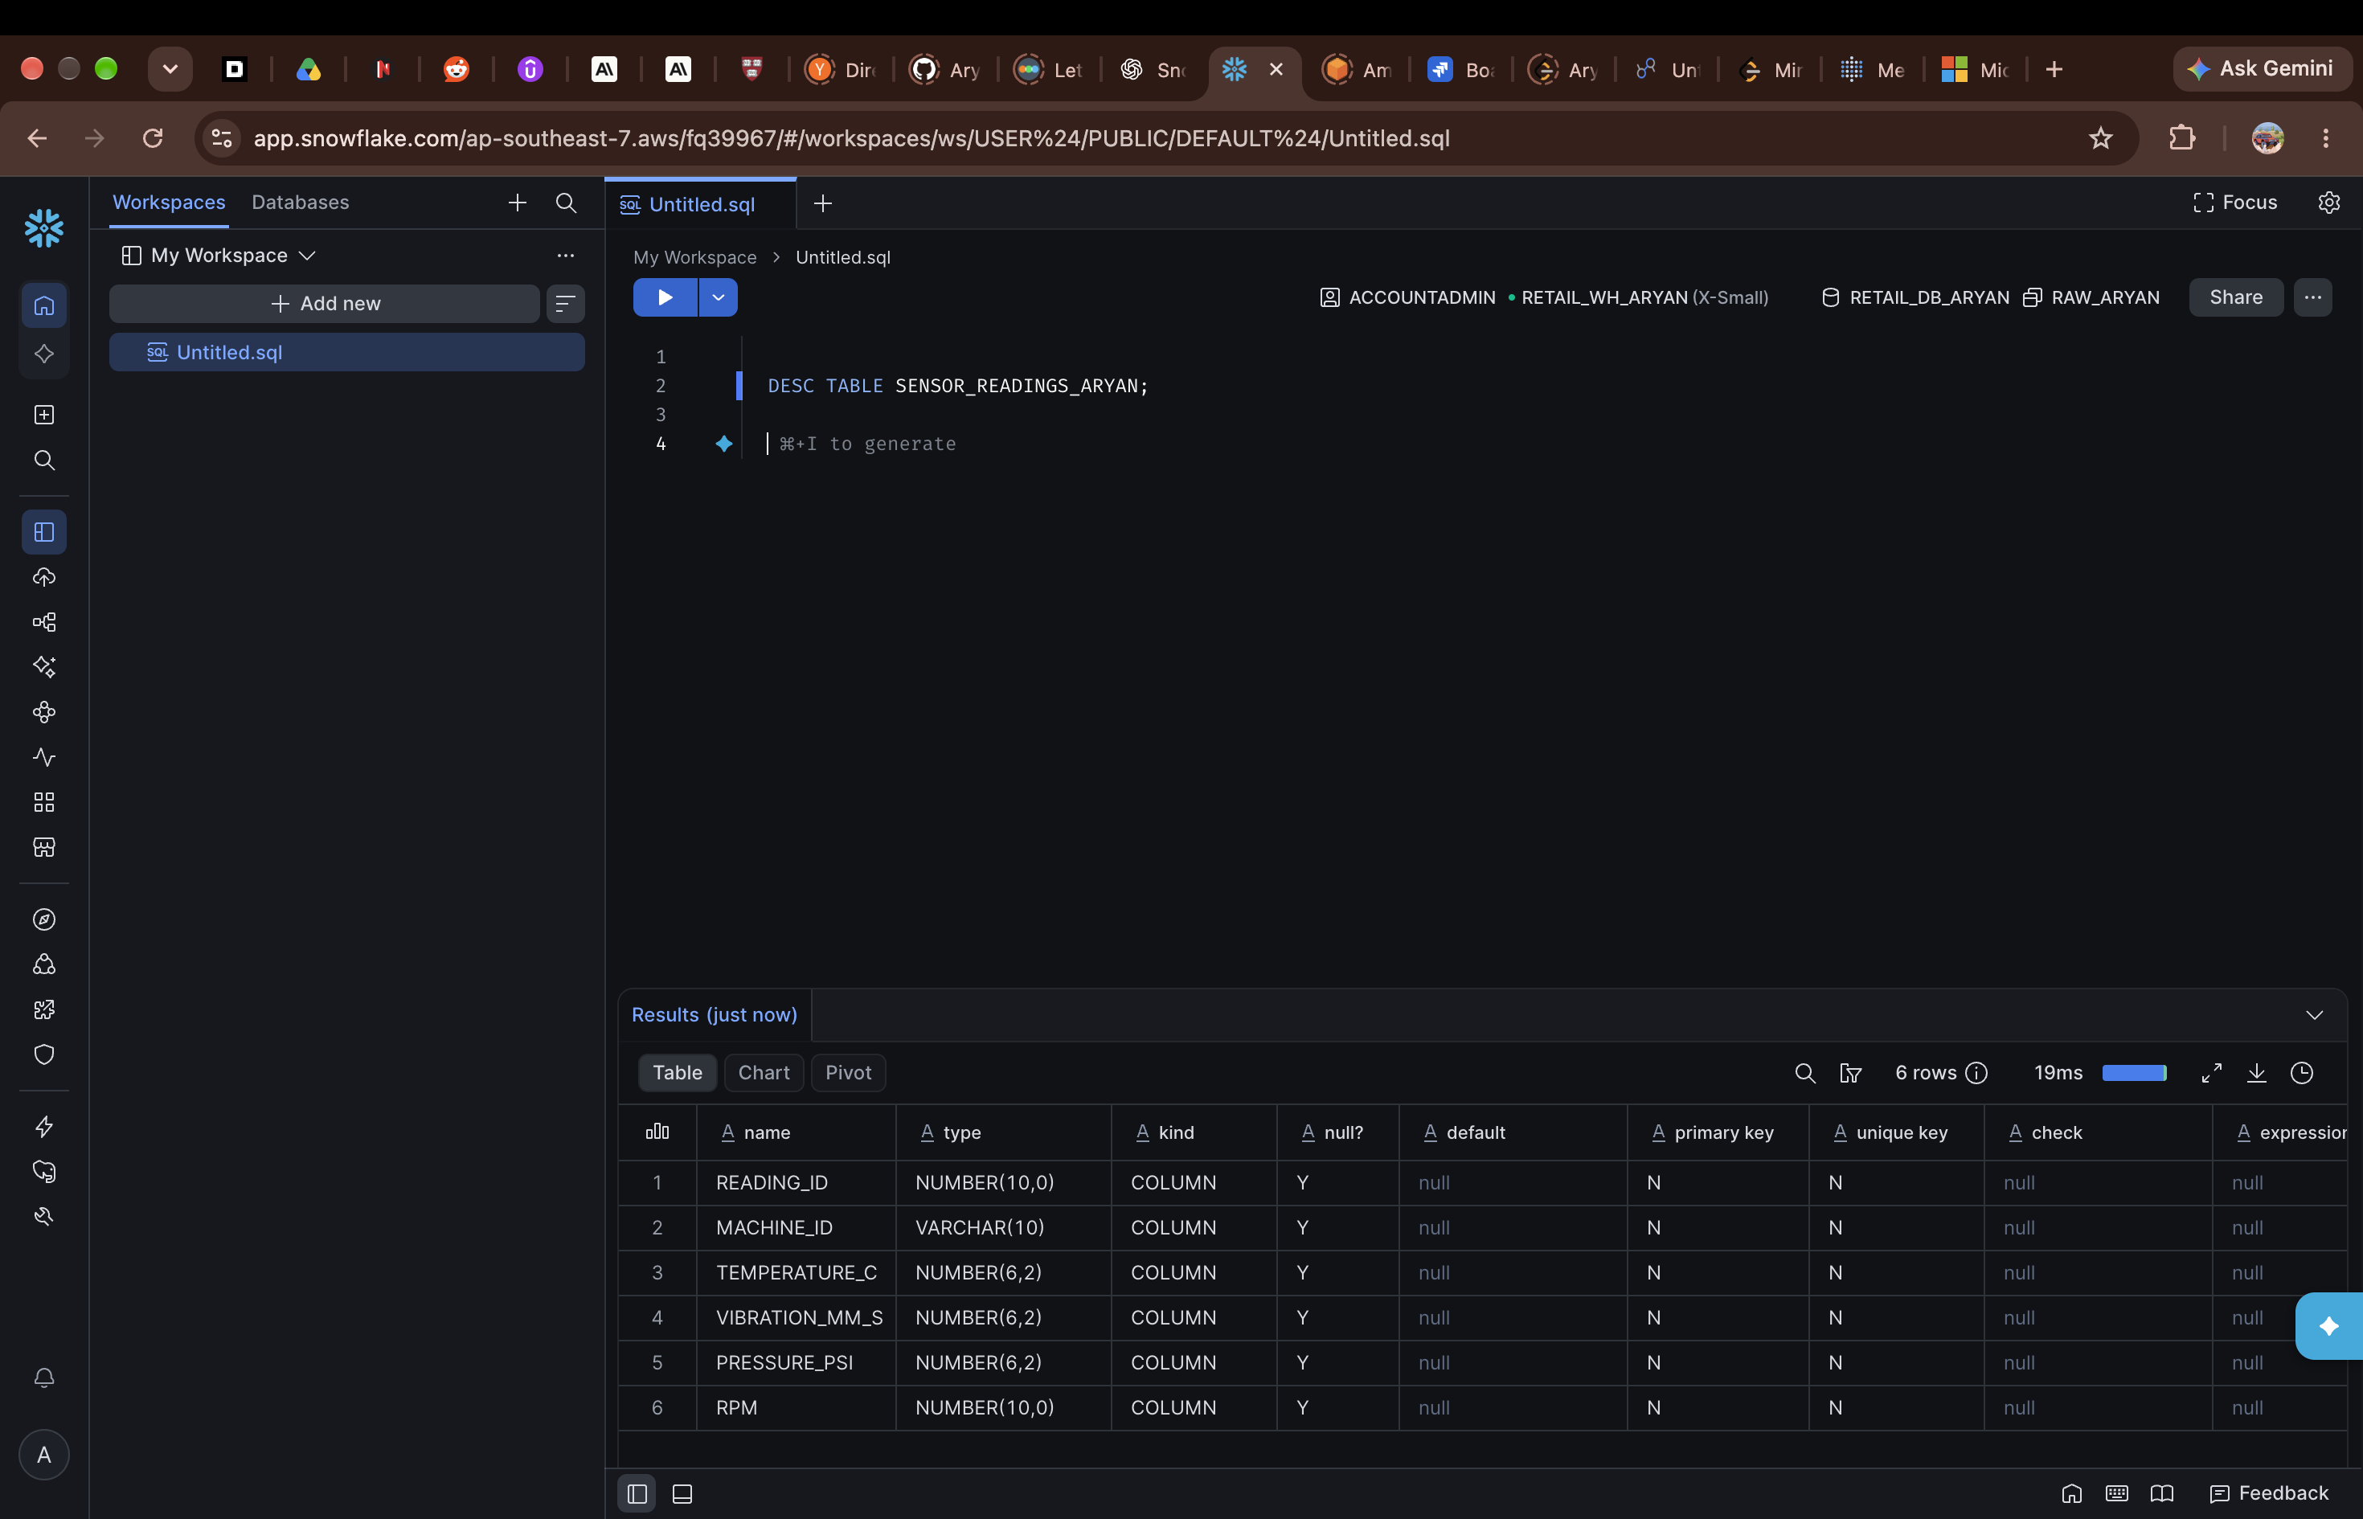
Figure 4 — Structure of SENSOR_READINGS_ARYAN.
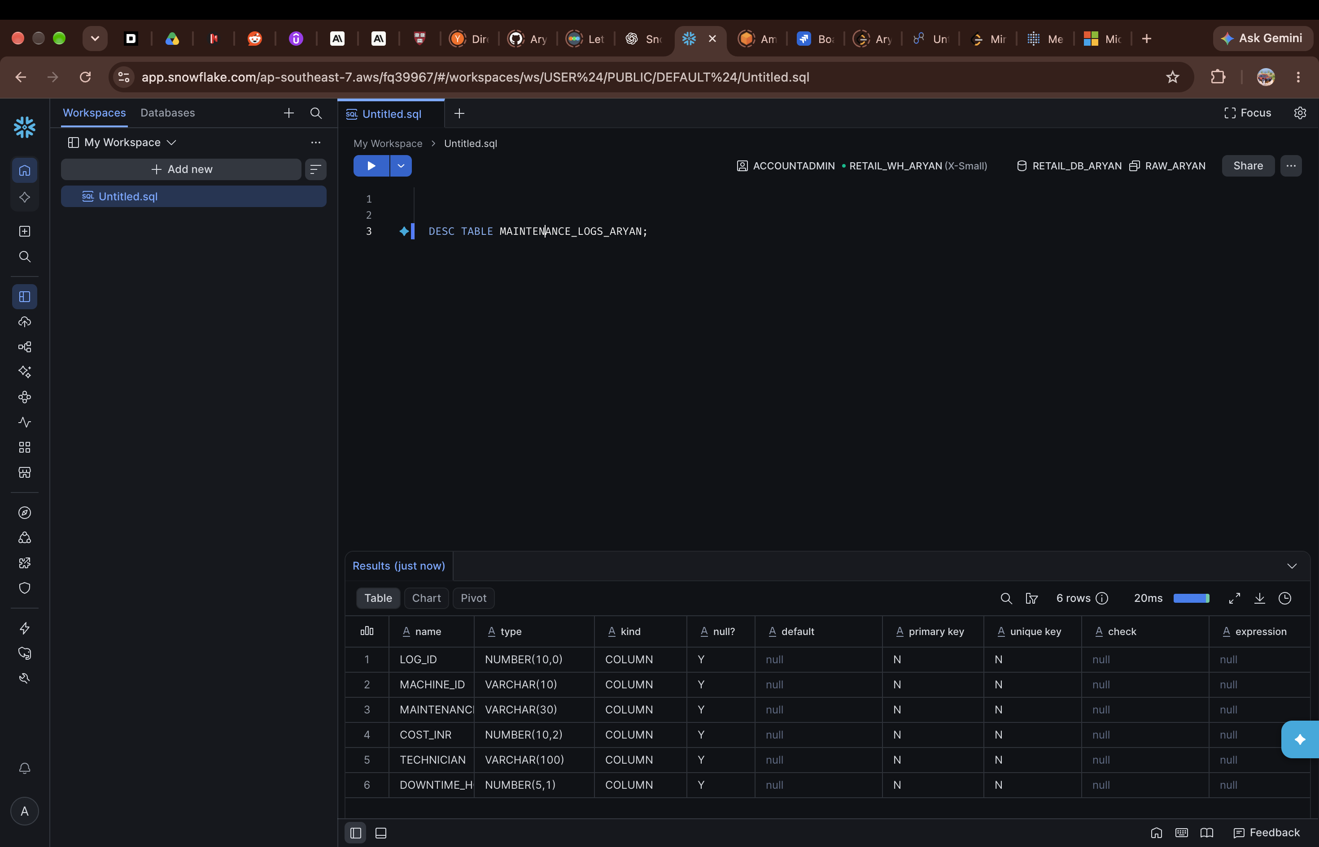
Figure 5 — Structure of MAINTENANCE_LOGS_ARYAN.
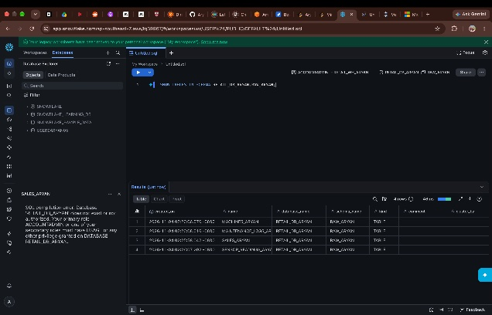
Figure 6 — SHOW TABLES, listing the tables in RAW_ARYAN.

4. Loading the data
The three CSVs were uploaded to ARYAN_STAGE first. The stage contents were checked with LIST @ARYAN_STAGE, and each file was then loaded into its table with COPY INTO, using ARYAN_CSV_FORMAT. The load history was also checked to confirm that the loads had completed, rather than relying only on the upload screen:
SELECT * FROM INFORMATION_SCHEMA.LOAD_HISTORY ORDER BY LAST_LOAD_TIME DESC;
All three tables came back as LOADED on 2026-11-04.
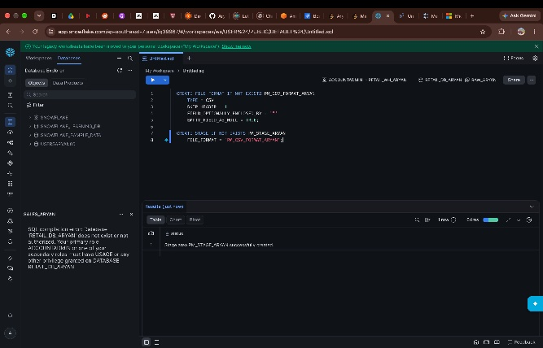
Figure 7 — Creating the CSV file format and the stage used for loading the files.
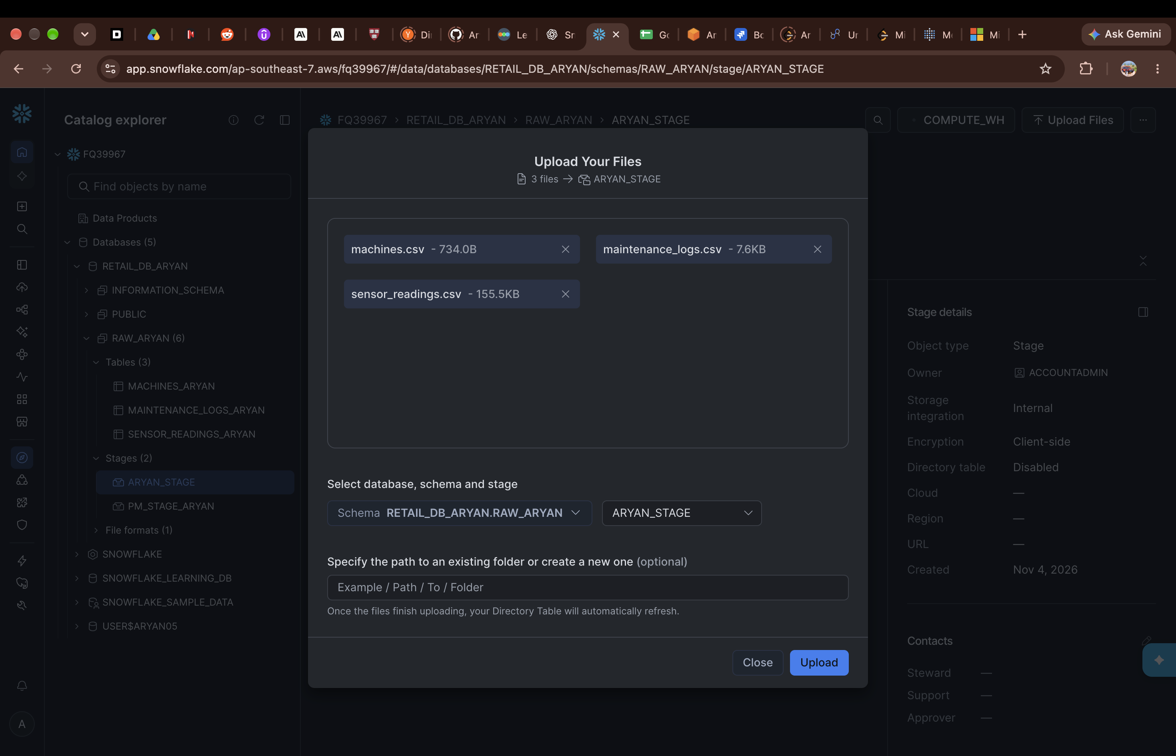
Figure 8 — Uploading the three CSV files to ARYAN_STAGE.
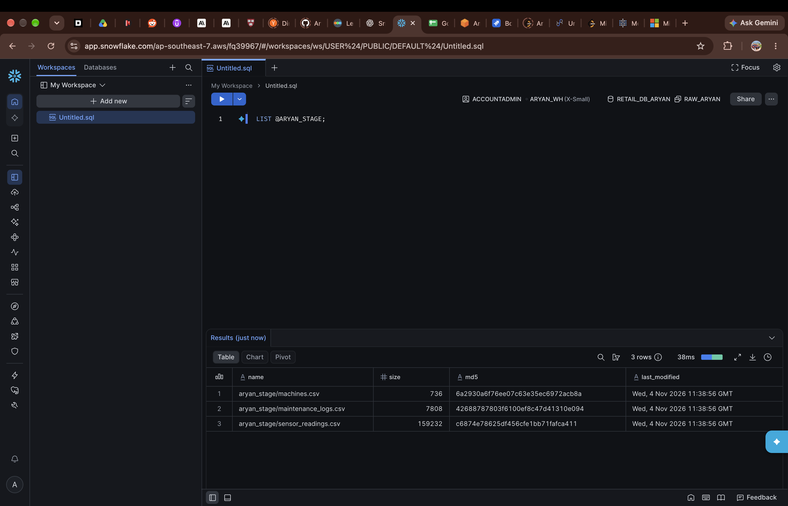
Figure 9 — LIST @ARYAN_STAGE, showing the three files in the stage.
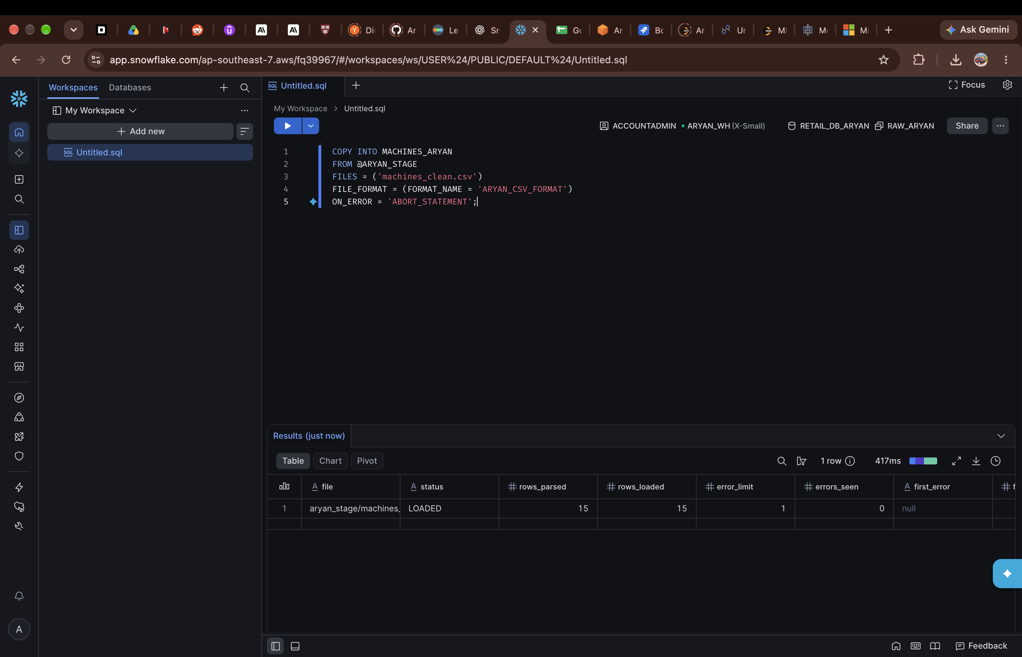
Figure 10 — COPY INTO MACHINES_ARYAN from @ARYAN_STAGE — 15 rows loaded.
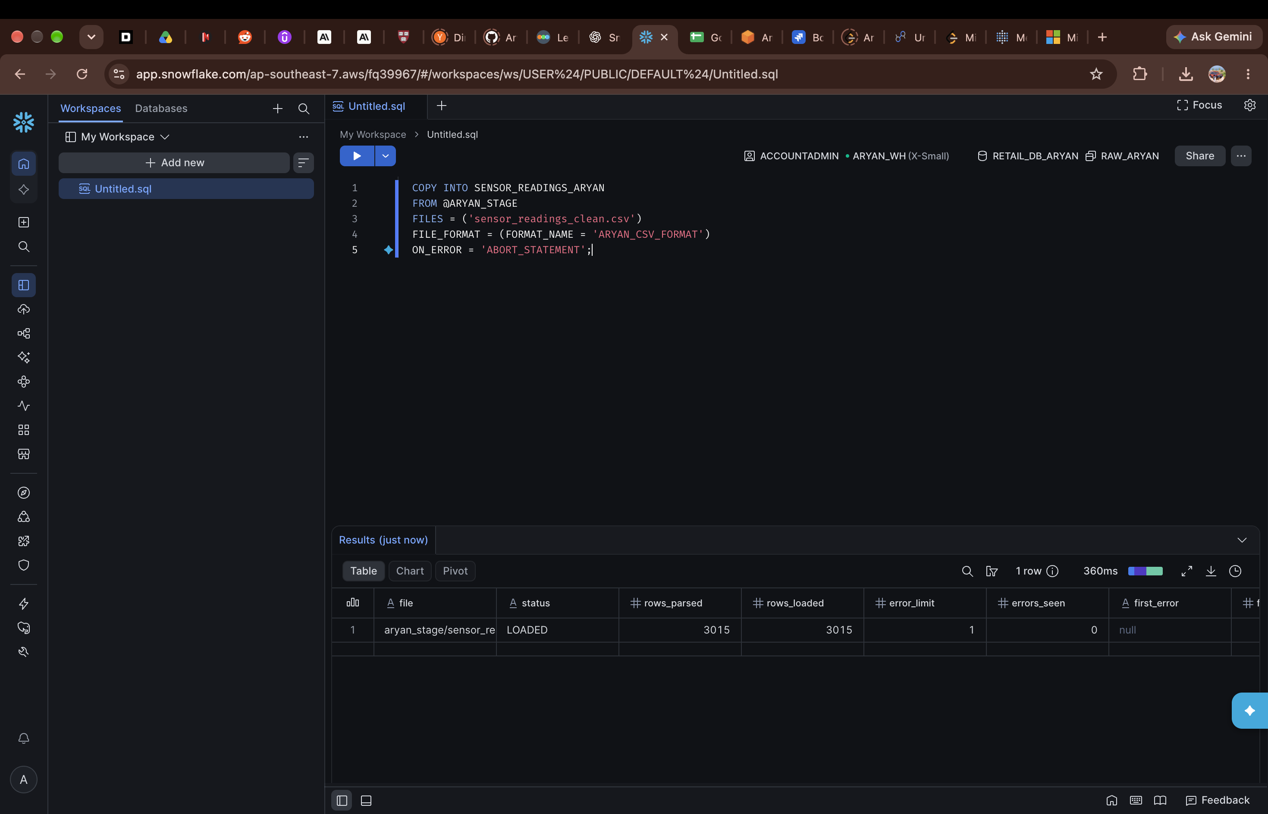
Figure 11 — COPY INTO SENSOR_READINGS_ARYAN from @ARYAN_STAGE — 3,015 rows loaded.
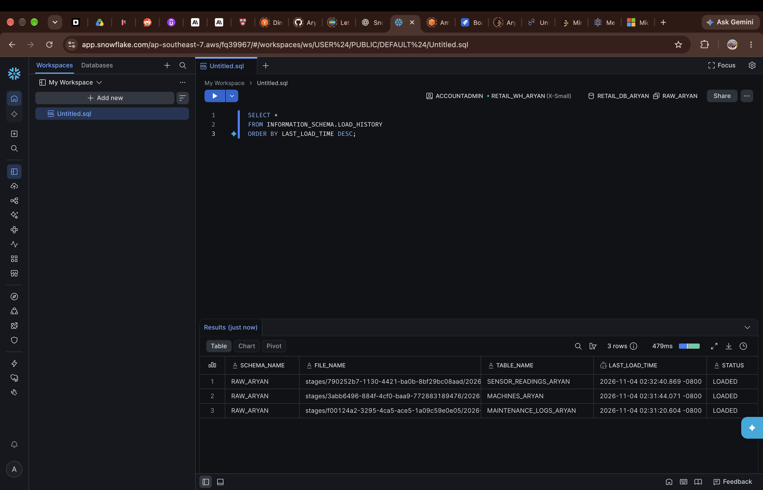
Figure 12 — Load history showing all three tables as LOADED.
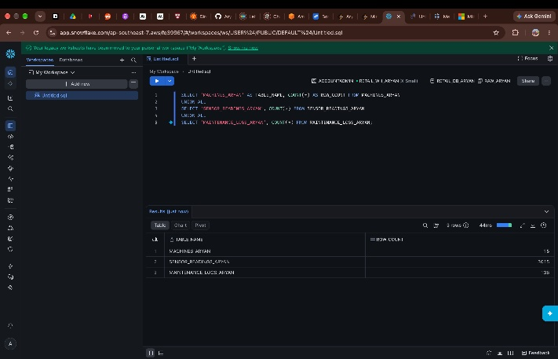
Figure 13 — Row counts after loading: 15 machines, 3,015 sensor readings and 138 maintenance logs.

5. Validation checks
Three basic checks were run on the raw data, and each one found an issue.

Nulls
In the sensor readings, temperature was missing in 61 rows and vibration in 30 rows. Machine ID, pressure and RPM were fine — no nulls there.
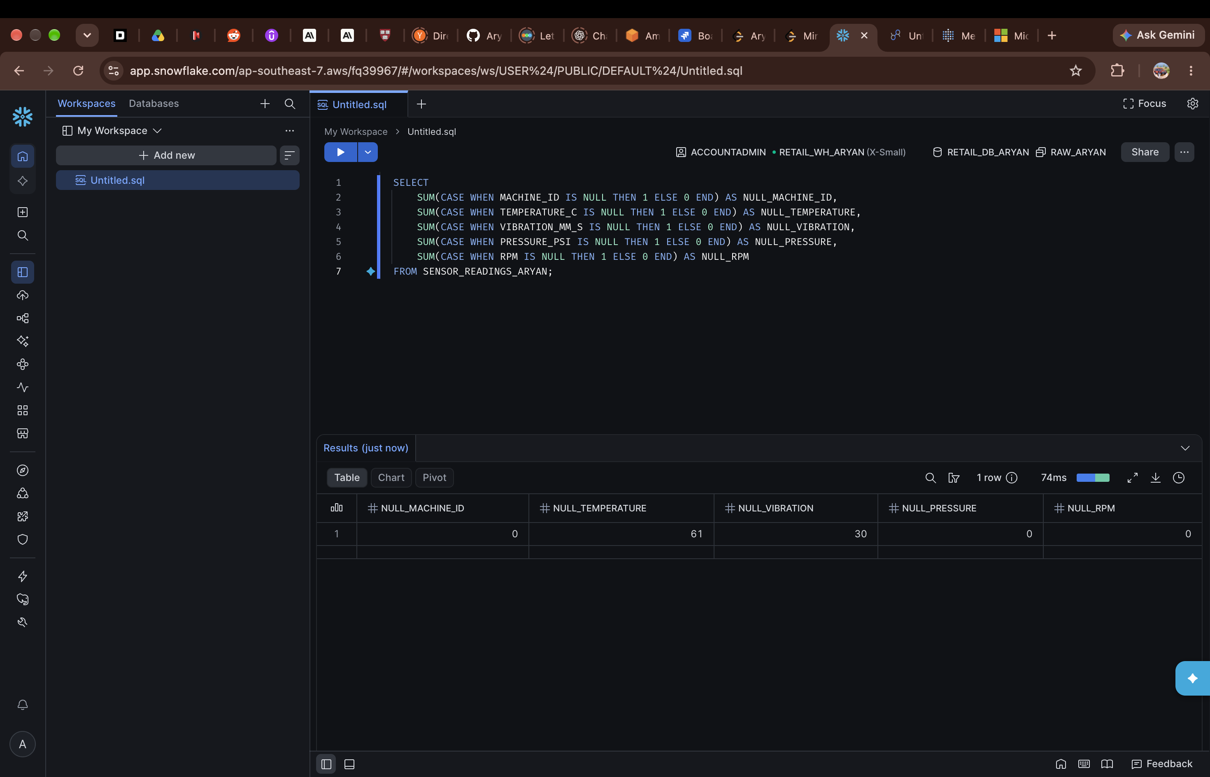
Figure 14 — Null check on SENSOR_READINGS_ARYAN: 61 missing temperatures, 30 missing vibrations.

Duplicates
The sensor table had 3,015 rows but only 3,000 distinct READING_IDs, so 15 rows were duplicates.
SELECT COUNT(*) AS TOTAL_ROWS, COUNT(DISTINCT READING_ID) AS DISTINCT_ROWS
FROM SENSOR_READINGS_ARYAN; -- 3015 vs 3000
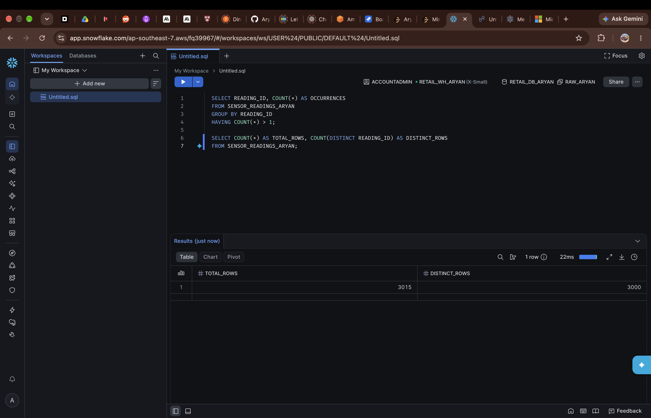
Figure 15 — 3,015 total rows against 3,000 distinct readings.

Logs for a machine that doesn't exist
Joining the maintenance logs back to the machines table showed 3 logs for machine M999, which is not present in MACHINES_ARYAN. The log IDs were 17, 121 and 124. These logs could not be used for machine-level analysis, so they were flagged during cleaning rather than being dropped without a record.
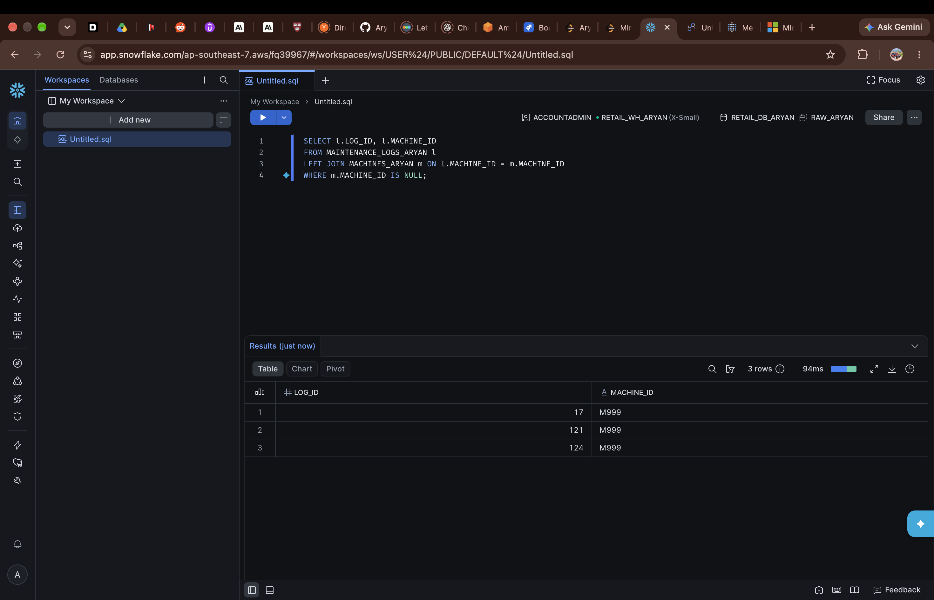
Figure 16 — The 3 logs pointing to the unknown machine M999.

6. Cleaning the data

Sensor data — SENSOR_CLEAN_ARYAN
A clean version of the sensor table was created. SELECT DISTINCT removed the duplicates, and missing temperature and vibration values were filled with the machine's own average, using COALESCE with a window average over MACHINE_ID. This brought the table down to 3,000 rows, matching the distinct count from the check above.
CREATE OR REPLACE TABLE SENSOR_CLEAN_ARYAN AS
SELECT DISTINCT READING_ID, MACHINE_ID,
COALESCE(TEMPERATURE_C, AVG(TEMPERATURE_C) OVER (PARTITION BY MACHINE_ID)) AS TEMPERATURE_C,
COALESCE(VIBRATION_MM_S, AVG(VIBRATION_MM_S) OVER (PARTITION BY MACHINE_ID)) AS VIBRATION_MM_S,
PRESSURE_PSI, RPM
FROM SENSOR_READINGS_ARYAN;
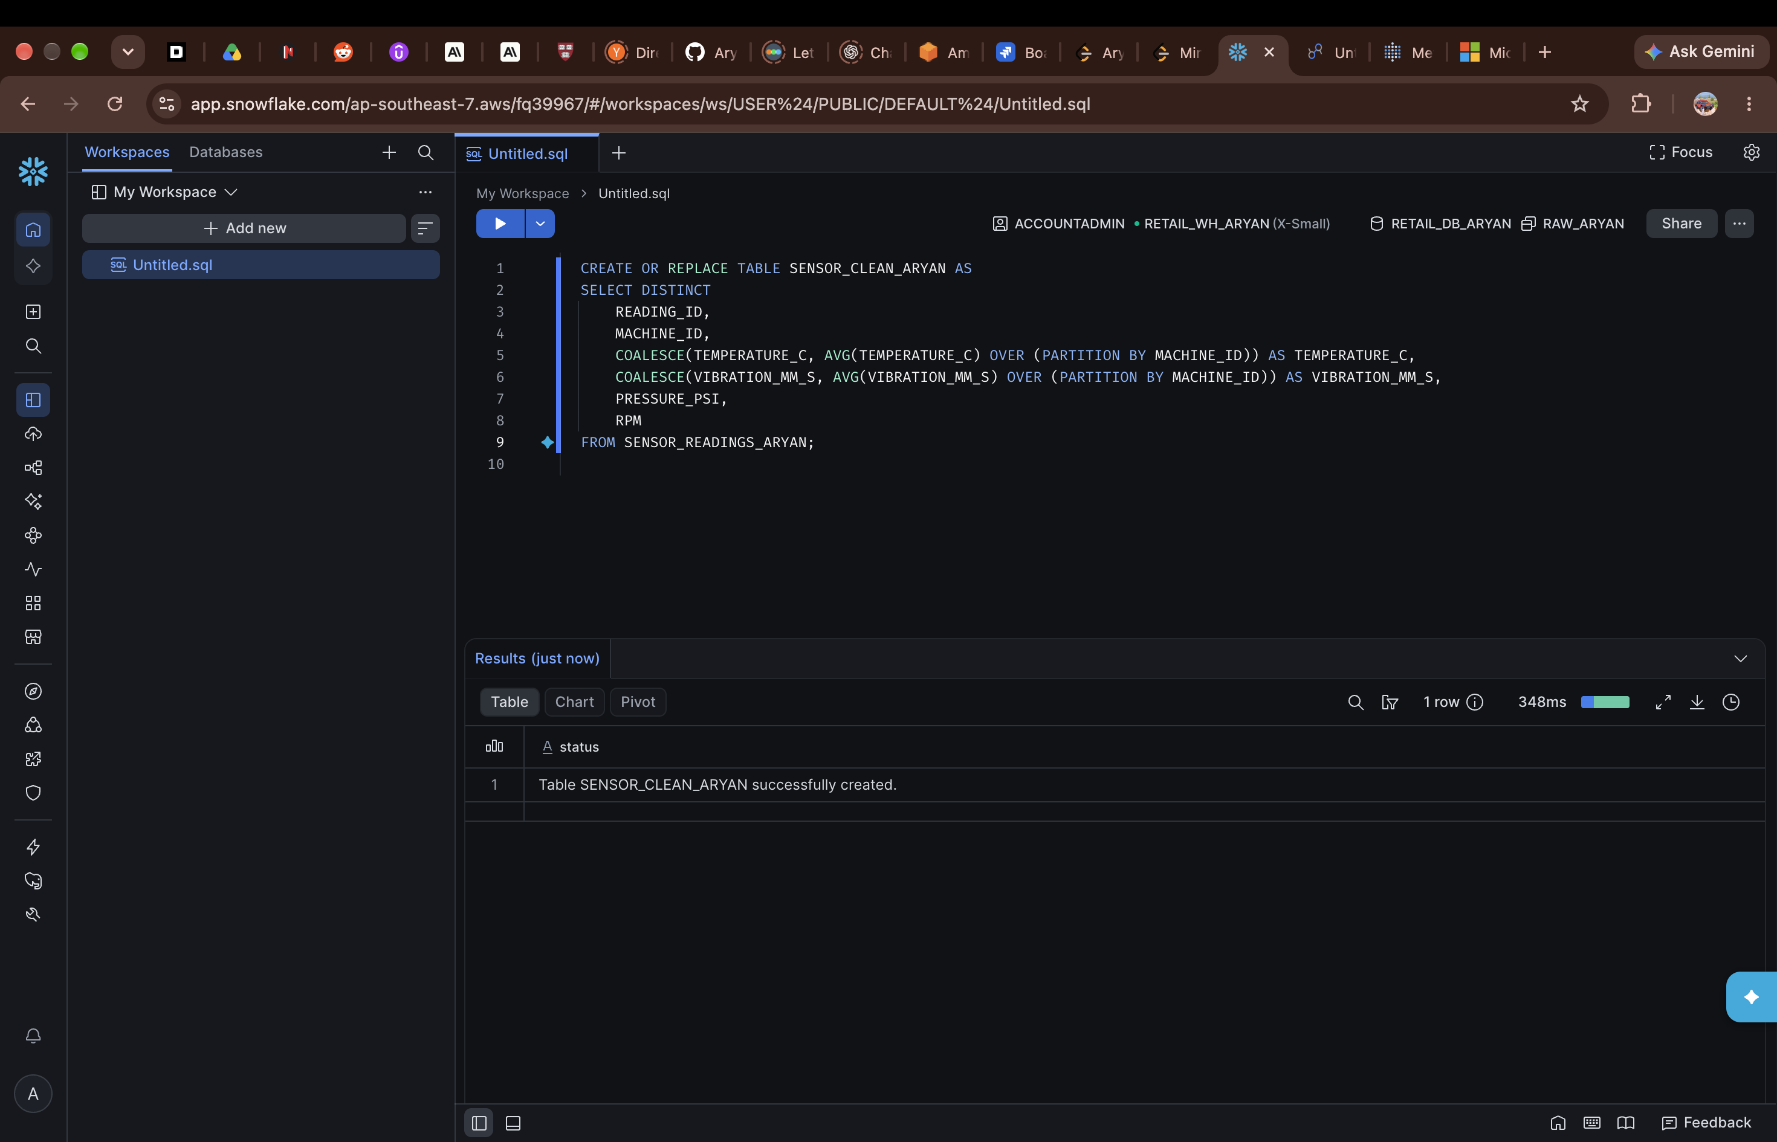
Figure 17 — Creating SENSOR_CLEAN_ARYAN.
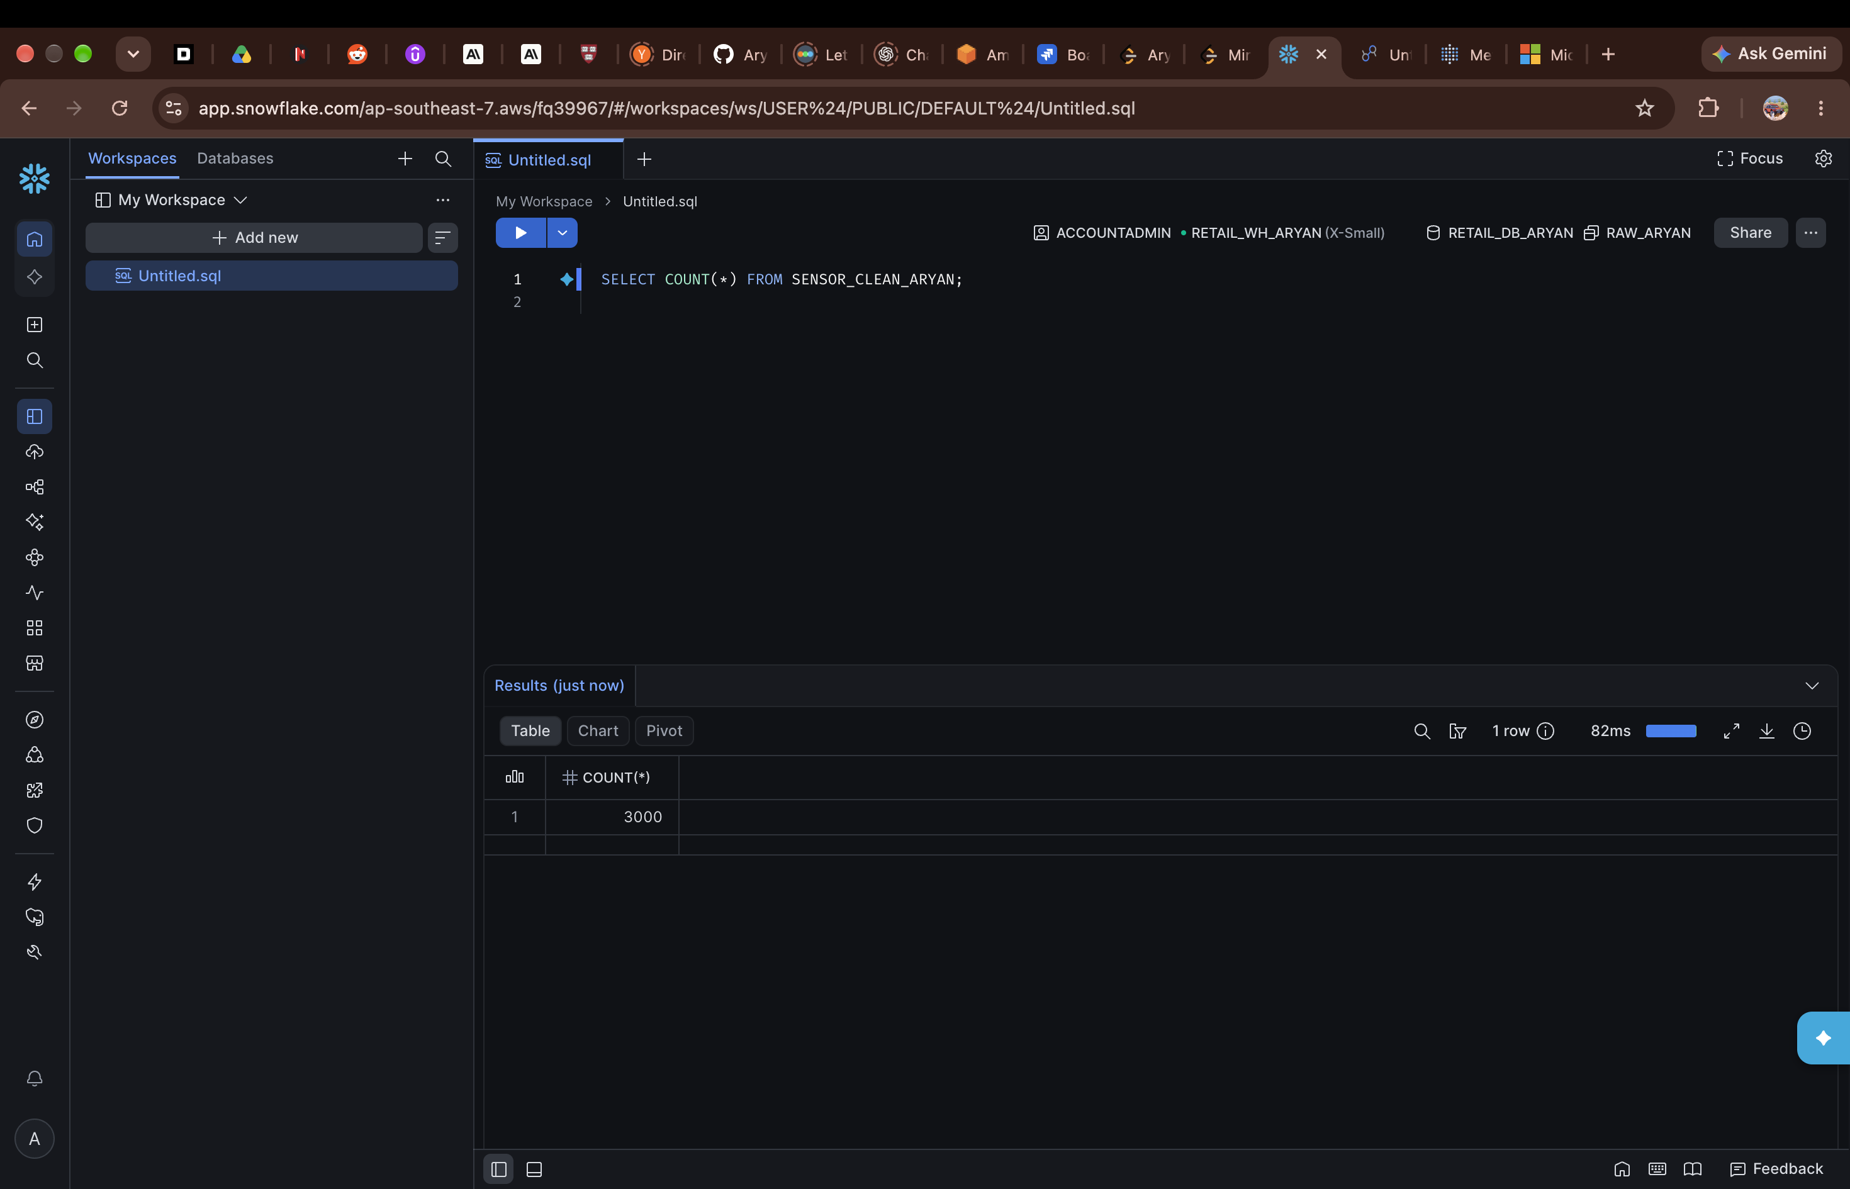
Figure 18 — After cleaning, SENSOR_CLEAN_ARYAN has 3,000 rows.

Maintenance data — MAINTENANCE_CLEAN_ARYAN
For maintenance, a view was used instead of a table. The view keeps all 138 logs and adds a column, IS_VALID_MACHINE, which is TRUE only if the machine actually exists. This gave 135 valid logs, with the 3 M999 logs marked FALSE, so later queries could filter on that column.
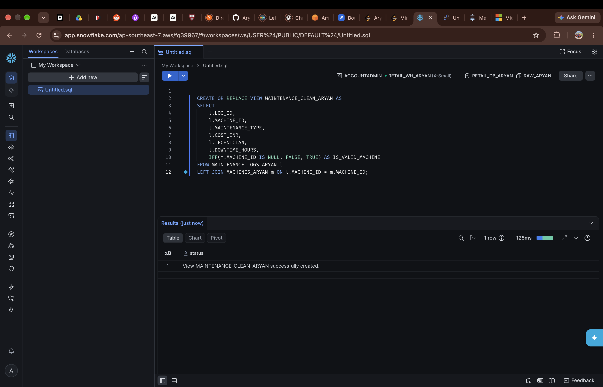
Figure 19 — Creating the MAINTENANCE_CLEAN_ARYAN view with the IS_VALID_MACHINE flag.
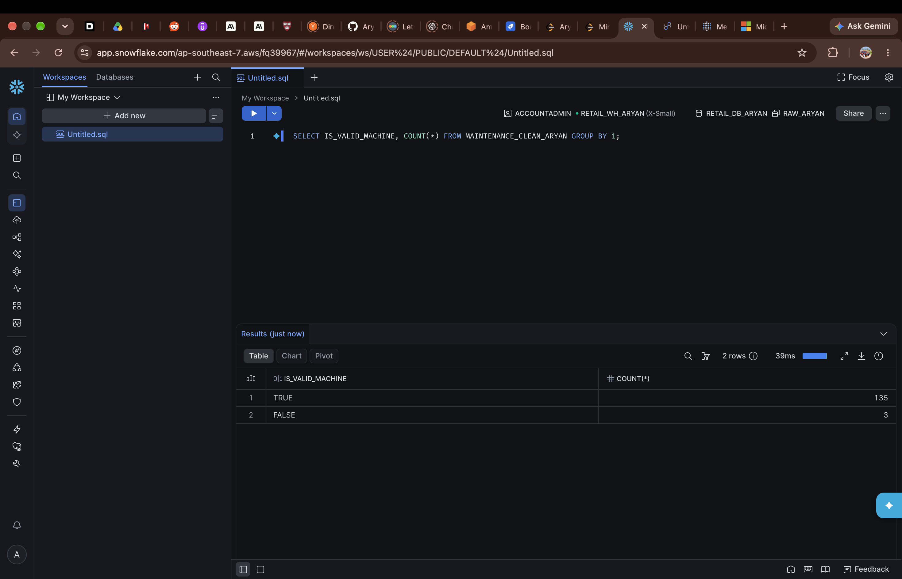
Figure 20 — The view splits the logs into 135 valid and 3 invalid.

7. Analysis findings
The analysis was run on the clean tables, not the raw ones, and only valid machines were included wherever cost was involved. A few points stood out.
On the sensor side, Industrial Pumps had the highest average vibration at 3.06 mm/s, and Hydraulic Presses the lowest at 2.15. Conveyor Motors ran hottest, at 67.96 °C on average, and also had the highest pressure.
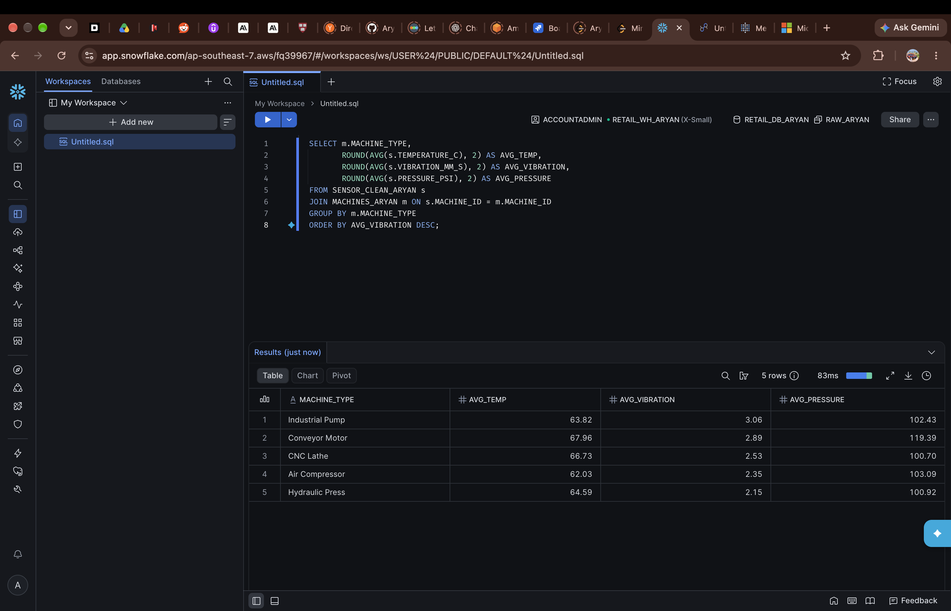
Figure 21 — Average temperature, vibration and pressure by machine type.
Machine type | Events | Total cost (INR) | Avg downtime (hrs)
Air Compressor | 53 | 12,75,260.63 | 6.23
Hydraulic Press | 46 | 8,86,547.44 | 5.64
CNC Lathe | 22 | 5,66,260.41 | 5.78
Industrial Pump | 7 | 1,94,926.78 | 4.79
Conveyor Motor | 7 | 1,72,435.93 | 7.61

Air Compressors cost the most to maintain overall — 53 jobs and about ₹12.75 lakh in total. Conveyor Motors were the opposite: only 7 jobs, but each one took the longest, 7.61 hours on average.
Looking at individual machines, the ones with the highest vibration — M012, M010, M015 and M001 — also tended to have higher maintenance costs. M001, for example, averaged 2.93 mm/s vibration and had 10 maintenance jobs costing ₹2,41,165.14 in total. So vibration looks like a useful early warning sign here, even if it's not proof on its own.
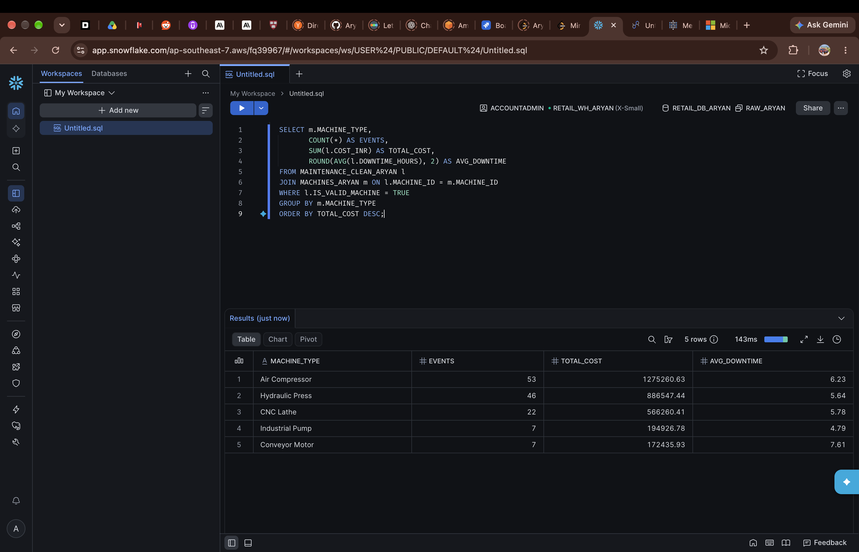
Figure 22 — Maintenance cost and downtime by machine type, valid machines only.
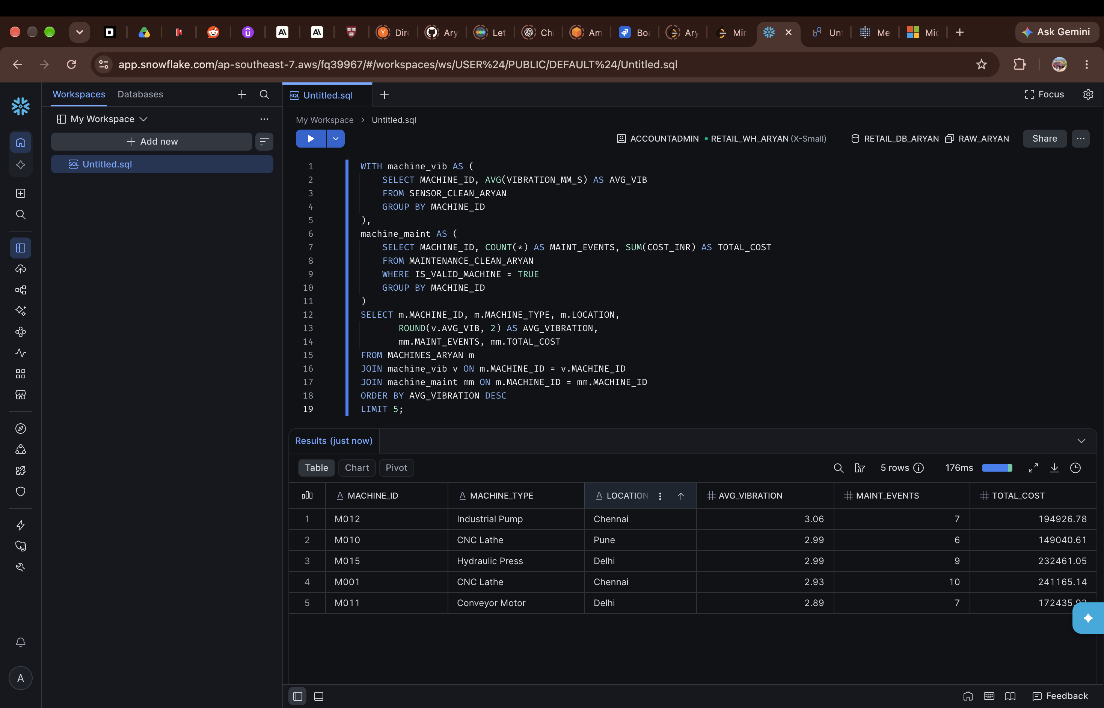
Figure 23 — Top 5 machines by average vibration, with their maintenance events and total cost.
By technician, Vikram Singh and Ravi Kumar handled the most jobs, 30 each, and Mohammed Ali's jobs had the longest average downtime, at 6.65 hours.
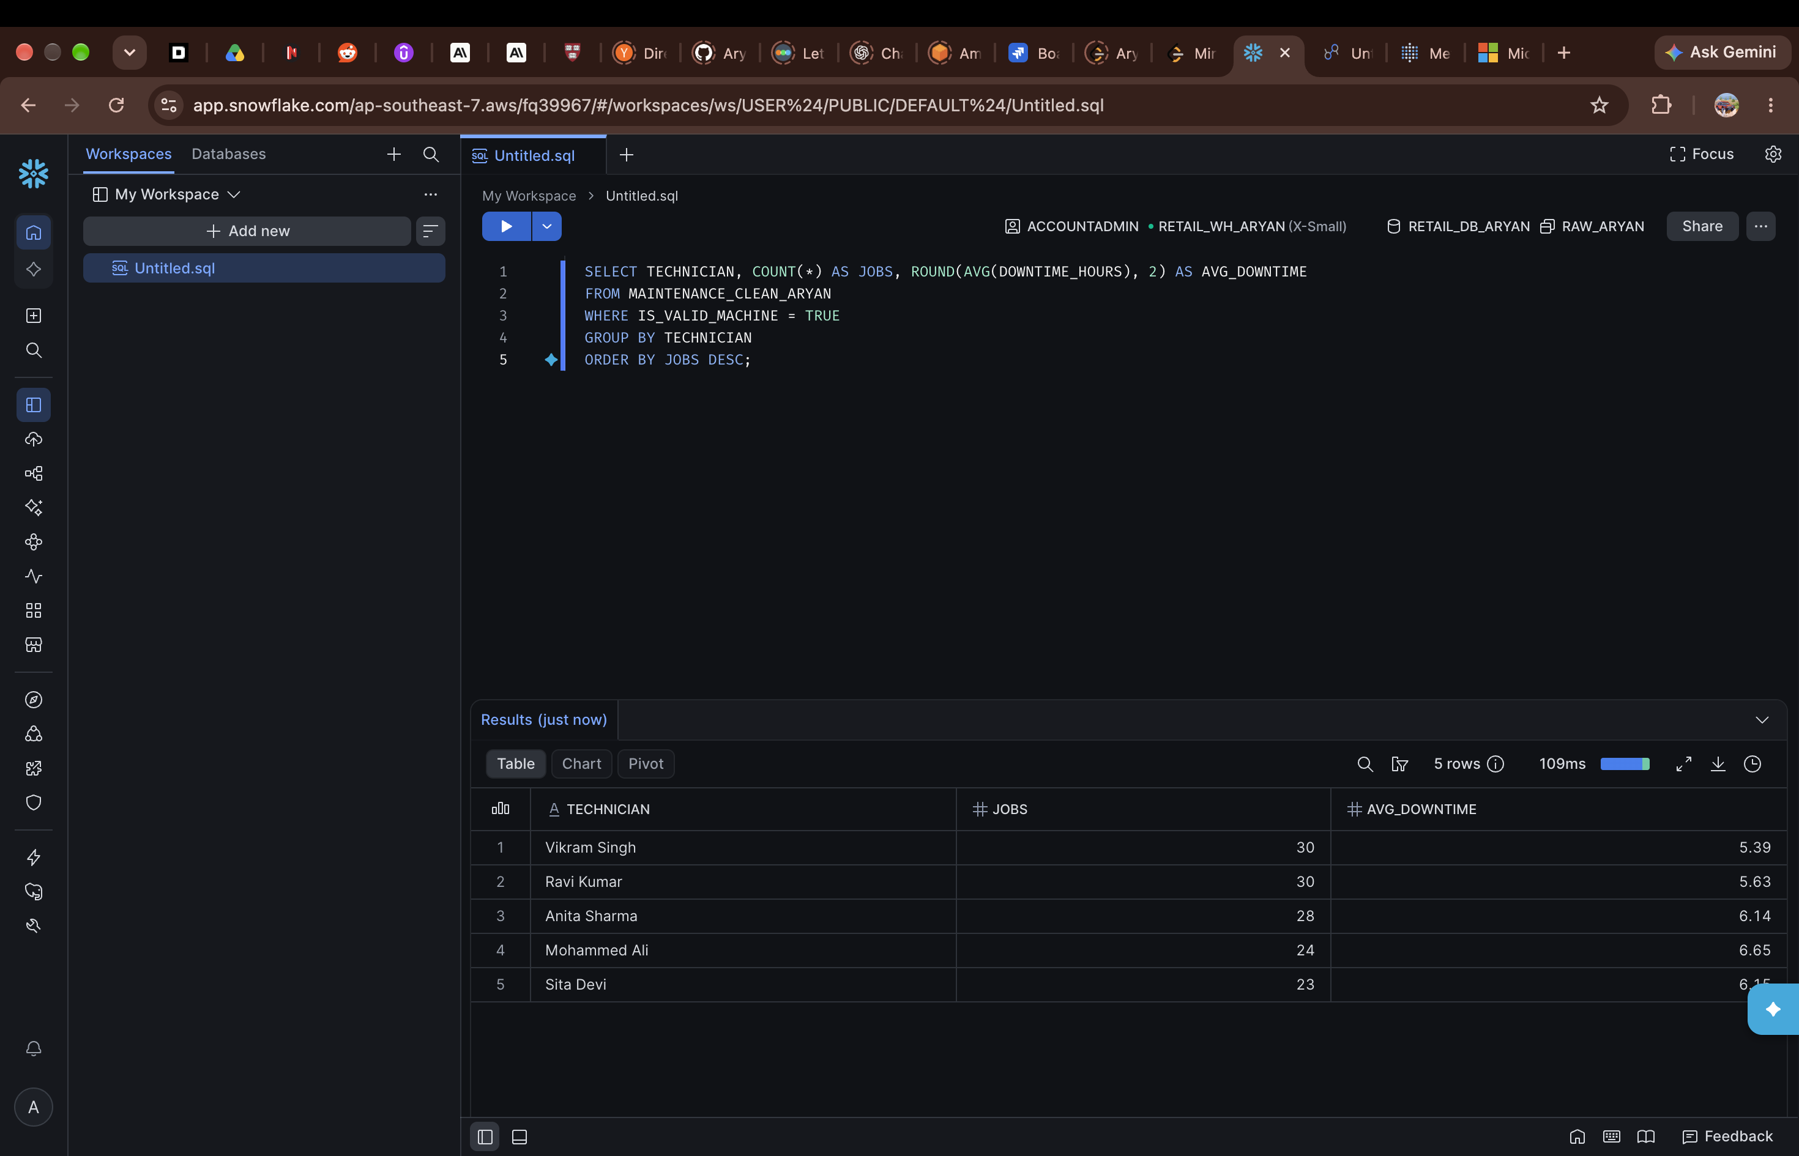
Figure 24 — Jobs and average downtime by technician, valid machines only.

8. Correcting the main query
The query was intended to show, for each machine type and location, how many readings there are, the average vibration, and the total maintenance cost.

The first version was wrong
The first query joined the raw sensor readings directly to the maintenance logs for that machine, and grouped the results afterwards. With that structure, each reading is repeated once for every maintenance log, so SUM(COST_INR) counts the same cost again and again. The totals were clearly wrong — over ₹12.66 crore was shown for Air Compressors in Chennai alone. The query also ran on raw data, so duplicates and the M999 logs were included.
Before the two versions were compared, the result cache was turned off, so both queries actually ran instead of one reusing a cached result.
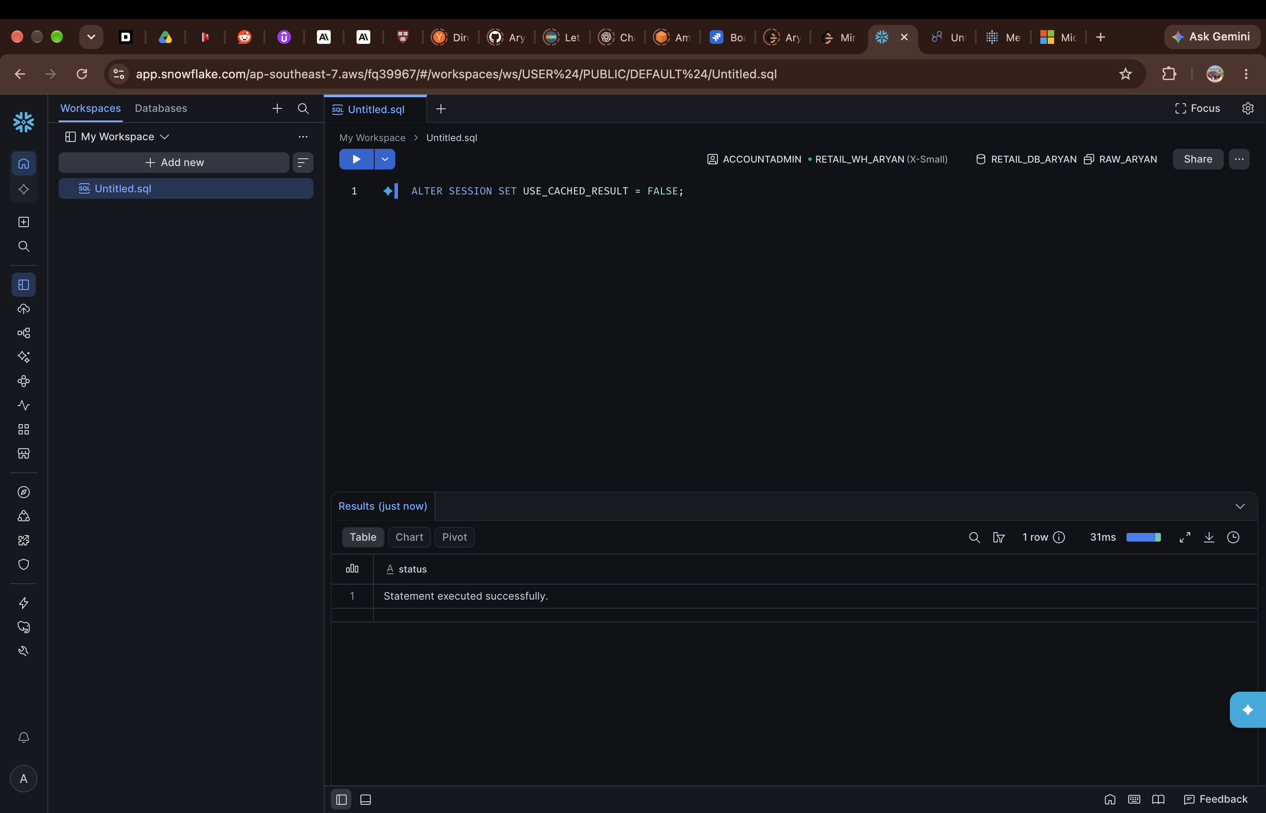
Figure 25 — Turning the result cache off before comparing the queries.
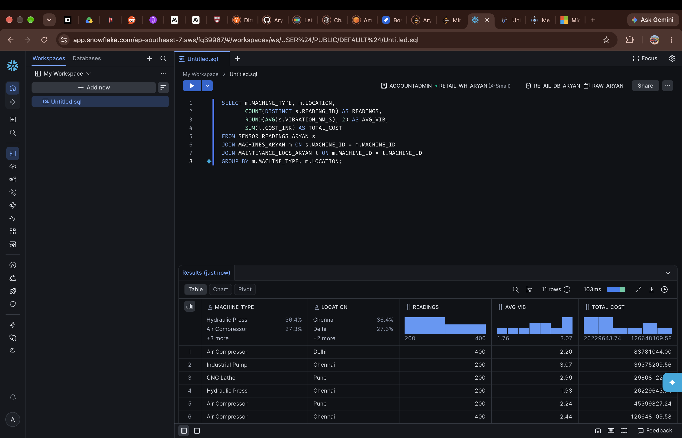
Figure 26 — First version: direct join on the raw tables, with clearly inflated cost totals.

Changes made
- Each table was aggregated by MACHINE_ID first, in two separate CTEs (sensor_agg and maint_agg), and the join was applied after that. With one row per machine from each side, the cost is counted once.
- The clean tables were used instead of the raw ones.
- Invalid logs were filtered out inside the maintenance CTE, with WHERE IS_VALID_MACHINE = TRUE, before aggregation.
After these changes, the numbers were consistent. For example, CNC Lathes in Chennai came out as 400 readings, 2.30 average vibration and ₹4,17,219.80 in total maintenance cost — a realistic figure compared with the crore-level totals from the first version.
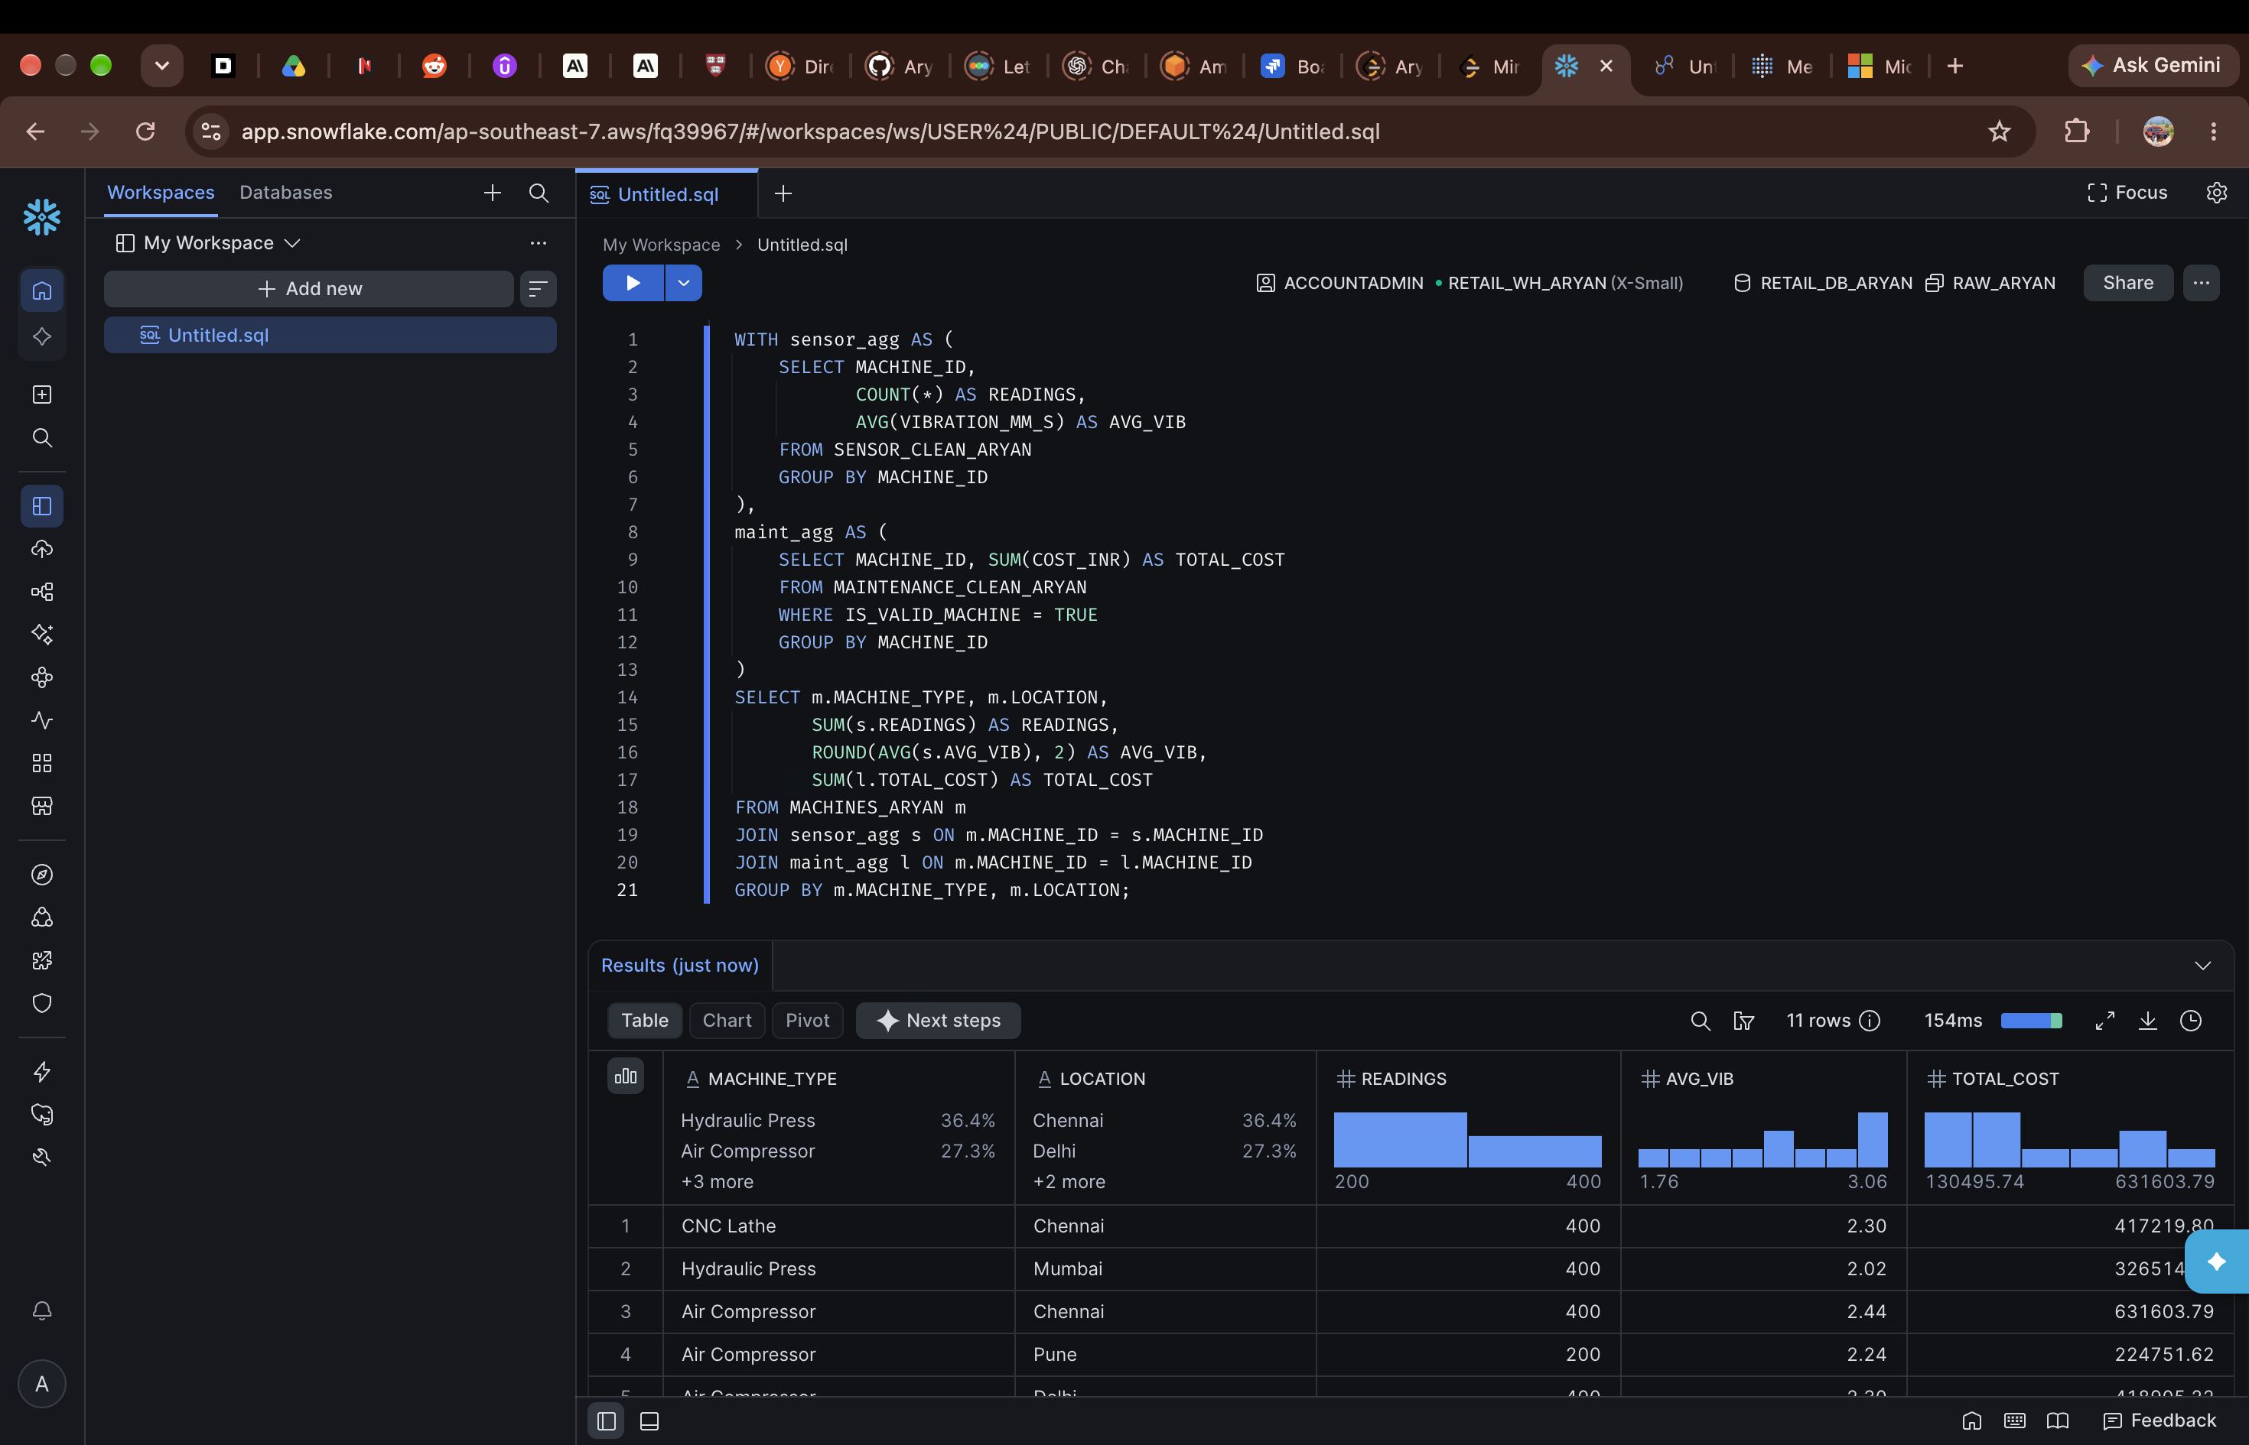
Figure 27 — Rewritten query using pre-aggregated CTEs on the clean data.
The main point from this part is that join order matters. Joining first and aggregating later on tables like these can produce a query that runs without errors but still returns the wrong answer.

